|  |  |
| --- | --- |
|  | Master of Applied Computing  COMP-8117  Advanced Software Engineering Topics |
| School of Computer Science https://cs.uwindsor.ca | Dr. Usama Mir – [Usama.Mir@uwindsor.ca](mailto:Usama.Mir@uwindsor.ca)  Office Hours: Wednesday and Thursday (10.00am – 1.00pm EST) |



**Assignment/Lab 3 – System Test Categories**

1. **Total Marks = 48 (will be adjusted to 3% accordingly)**
2. **Submission Date = July 20, 2022**
3. **Submission = Only via blackboard**
4. **One submission per group**
5. **Only one attempt**
6. **Copying from Internet and other sources will result in 0 marks**
7. **Submission Format = MS Word**
8. **No folder/zip uploads are allowed**

ASET ASSIGNMENT-3, Section-1, Group-2

1.Arun Reddy Nalla (Student ID: 110088379)

2.Harsh Bharath Nimmakuri (Student ID: 110088953)

3.Kalyan Venkatesh Poludasu (Student ID: 110089120)

4.Veera Venkata Bharat Kumar Vayitla (Student ID:110088432)

**Description**

Referring to Dr. Kobti’s slides on BB under Week 8 and our next week’s lecture (Lecture 9), there are following categories of system test cases:

1. Compatibility/Configuration/Conversion Testing
2. Configuration Testing
3. Document Testing
4. Facility Testing
5. Installability Testing
6. Performance Testing
7. Procedure Testing
8. Recovery Testing
9. Reliability Testing
10. Security Testing
11. Serviceability Testing
12. Storage Testing
13. Stress Testing
14. Usability Testing
15. Volume Testing

**Assignment/Lab Tasks**

For this lab, you need to work on the Configuration Testing, Installability Testing, Performance Testing, Security Testing, Stress Testing, and Volume Testing. For each category of testing:

1. You need to define it with an example in your own words. (2 x 6 = 12 marks)
2. Identify any open-source tools that are suitable to perform each testing category (at least two tools per category). (2 x 6 = 12 marks)
3. In a few lines, justify which tool would be suitable for your ASE class project and why. You should consider at least 4 tools here. (2 x 4 = 8 marks)
4. Briefly describe where and how you would be conducting each test using these tools within your ASE class project. (4 x 4 = 16 marks)
5. You need to define it with an example in your own words. (2 x 6 = 12 marks)

**Configuration Testing:**

Configuration testing is a type of software testing that evaluates how well a system works with various combinations of hardware and software to decide the ideal setup for the system that will allow it to operate flawlessly and meet all of its functional criteria.

The software will test in the following software and hardware’s and check whether it works fine in all the conditions:

* Different operating system and their versions: Windows XP, Windows 7 32/64 bits , Windows 8 32/64, windows 10, windows 11, MacOS, Linux OS etc.
* Various browsers: chrome, safari Microsoft edge and Firefox etc,.
* Different CPU types, different hard drive types, different RAM sizes, and different supported drivers

For example, consider the Facebook application which is built on React Native Framework.

Now, the mobile app should be test on different OS like android, IOS.

Also, the app should be test in different hardware models different RAM capacity, storage, with minimum and maximum setting (likes video/photo quality, screen refresh rate for scrolling etc)

Even for the web application, it should test on different browsers like chrome, safari and Firefox etc.

**Installability Testing:**

* Installability testing is the type of testing that is used to determine whether the test items can be installed properly or not as necessary in different environments.
* We have installation requirements and guidelines provided in installation document for installing software. We will be testing these installation procedures mentioned in the document on the software.
* Few characteristics that are validated include diskspace, RAM, Type of OS…etc.
* This testing is so important because if the test item is not installed properly or facing issues with installation, it will affect the user’s perception, first experience and the ease to use installed software.
* The use of this testing is to check testcases and ensure that no module of program or application is untouched.
* Consider example of iMessage, a messaging service which only works on IOS but not on android. We can't install iMessage on Android because Apple uses a special end-to-end encryption system to secure messages.

**Security Testing:**

It is a type of software testing in which the test cases are devised to uncover vulnerabilities, threats, and hidden risks in the developed software.

It helps in ensuring the software free from any threats or risks that can cause a loss to user-sensitive data, revenue or company secrets

The test cases are performed to find any loopholes that bypass the software security

Main goal of security testing is:

1. Detecting possible security risks in the system

2. Measure the potential vulnerabilities of the system

3. Identify threats in the system

4. Helping developers to fix the identified threats

Types of security testing include

1. Vulnerability Scanning

2. Security Scanning

3. Penetration Testing

4. Risk Assessment

5. Security Auditing

6. Ethical Hacking

7. Posture Assessment

1. ***Vulnerability Scanning***:

It is performed with the help of automated software to scan a system against known vulnerabilities looking for potential points to exploit.

Mostly performed on a computer or a network. Can be authenticated scan or unauthenticated while network scanning.

2. ***Security Scanning:***

It helps in identifying network and security weakness and provide solutions to decrease the defects / risks. It can be performed in both manual and automated manner.

In most scenarios, Vulnerability Scanning and Security Scanning comes under one section and must be performed regularly.

3. ***Penetration Testing***

Also know as pen-test, is performed by a cyber-security expert to find vulnerabilities and threats. It is to be performed by an individual who has little-to-no knowledge of how system works.

4***. Risk assessment***

It involves analysing the identified risks / threats in the application. They are classified into 3 categories i.e., low, medium, high.

5. ***Security Auditing***

An assessment of organizations information system. It is done against a audit checklist of industry best practices. It can be a line-by-line code inspection too.

6. ***Ethical Hacking***

It involves an authorized attempt to gain unauthorized access to a computer system. It is performed by certified security experts known as 'white-hats'

7. ***Posture Assessment***

It refers to the security status of organization or network. It is calculated by parameters such as people, hardware, and software capabilities.

It is often described as security scanning, risk assessments and ethical hacking

Ex: In case of mobile applications, Security scanning is performed for invalid authentication of users, API calls and data storages

Ethical hackers are employed by finance, bank industries to find vulnerabilities in the system structure

**Performance Testing:**

Performance testing is a testing technique where we see how much speed, how responsive, how stable, and how scalable the application gives under a certain workload.

**Example:**

We can consider load testing and stress testing as performance testing.

**Load testing:**

To perform load test, we must consider the expected number of concurrent users of an application at any time. So that using an expected concurrent users count we can perform load test and check whether the application is able to handle the load. We can also perform load test on specific functionalities of an application. Let’s take an example of login functionality and business gives an estimate that at any point of time maximum of 100000 customers will login, to test this we should have 100000 test user credentials and using test automation tool we an automate the login of 100000 users at a given time.

**Stress testing:**

In Stress testing we will test, does the system is capable of handling higher than expected traffic. From this we come to know whether the system is responsive beyond the expected limits. Lets take the same above example and pass 101000 users to login and ifit is working fine increase the count and recheck. This give to what extent the system can manage load beyond limits.

**Stress Testing:**

* Stress testing is the practice of evaluating the stability of the hardware or software under conditions of high load. This testing is carried out to determine the exact number of users, server requests, etc. at which the system will fail, as well as the appropriate error handling at that time.
* The primary reason of this testing is to test data recovery solution in case of system failure.
* Testing under stress determines whether the system will save the data to recover it later before it crashes. This test primarily evaluates the system's robustness and error handling under conditions of extremely high load.
* Consider Amazon application during the Black day sale. The application receives large number of requests on those day in a shorter duration. Therefore, stress testing can assist in identifying the application's breakpoint and in studying the application's behavior and crash recovery capabilities.

**Volume Testing:**

It is a type of testing, to check the data volume handled by the system / database. It is also called as 'Flood Testing', a part of non-functional testing performed to check the software its capacity against huge volumes of dataset.

**Objective of volume testing:**

identify the problem that'll occur with large volumes of data

check the system performance against huge volumes of data

It helps in identifying the capacity of the system (normal / heavy)

If the application tends to handle data in MBs or GBs, then this testing should be performed

**Few challenges:**

Creating a replica of the main server during DEV/UAT phase is difficult because of budget issues

Network issues, Automation tools may infect the results

create the memory required to test the actual implementation is difficult

Ex:

If the application is based on a e-commerce application and is designed for 20K users. suppose for a festive season, the traffic increased to 40K-50K and the DB was slow to handle this much traffic. This kind of breakdowns can be avoided in volume testing

1. Identify any open-source tools that are suitable to perform each testing category (at least two tools per category). (2 x 6 = 12 marks)

**Configuration Testing:**

Testing tools used to configuration testing

* SolarWinds
* Puppet Configuration Tool

**Installability Testing:**

Testing tools used to Installabilitytesting

* RSpec
* Minitest

**Security Testing:**

Testing tools used to Security testing

* Zed Attack Proxy (ZAP)
* Mobile Security Framework (MobSF)

**Performance Testing:**

Testing tools used to Performance testing

* Apache JMeter
* Locust

**Stress Testing:**

Testing tools used to Stress testing

* Fiddler
* Load Tracer

**Volume Testing:**

Testing tools used to Volume testing

* NoSQLMap
* HammerDb

1. In a few lines, justify which tool would be suitable for your ASE class project and why. You should consider at least 4 tools here. (2 x 4 = 8 marks)

***Security Testing -*** Mobile Security Framework (MobSF)***:***

* Since the end-product of the project is a mobile application, Mobile Security Framework (MobSF) is preferred.
* It is developed mainly for the purpose of testing mobile application vulnerabilities on platforms like Android & iOS
* It is open source and is approved by OWASP (Open Web Application Security Project)
* It is hosted on local environment to protect sensitive data
* It supports in all phases of SDLC
* Once testing is performed, it provides with a summary of results in HTML / PDF format

**Configuration testing – SolarWinds**

* SolarWinds is a Server Configuration Monitor.
* This tool has different configuration for device.we need a select required configuration and test our project.
* These tool has log option to see all the configuration changes and also has a feature to compare these configuration
* we can use it to establish standard server and application setups for Linux and Windows and stop unwanted configuration modifications our servers and application.
* It will shorten the time spent troubleshooting, and increase team accountability

**Postman – functional testing:**

* Postman is an API testing tool
* It provides a great ease for API functional tests
* Supports all HTTP method calls
* It provides a feature collection where we can save our api calls and request body for reusing them
* We can create different testing environment.

**UI Testing- Android Bug Hunter:**

* A manual mobile testing tool called Bug Hunter was created primarily for UI testing Android apps.
* In addition to manual testers, Android developers and UI/UX designers can use it to examine the app or certain features before it moves on to the QA stage.
* Bug Hunter offers:
  + Guides & Rulers: Verify the UI components' alignment.
  + Grid: Establish the margins between and the sizes of the UI elements.
* UI is the first experience that user sees. If the UI is well aligned, it would create positive on the user and improves ease of use.
* So, this tool will be helpful for UI testing and check whether UI is well and good in the project.

1. Briefly describe where and how you would be conducting each test using these tools within your ASE class project. (4 x 4 = 16 marks)

**Security testing with MobSF:**

Step-1: During the Development phase / Testing phase, once the .apk file is ready, MobSF can be used

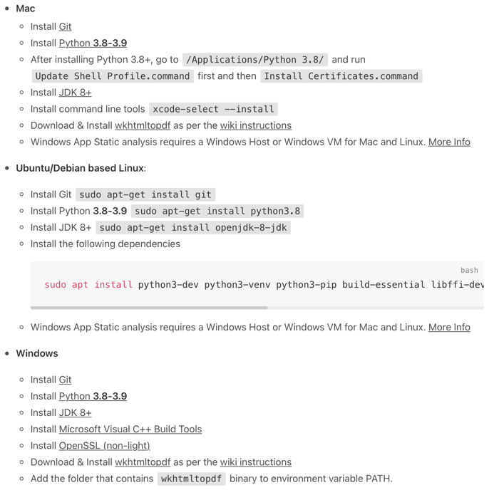Step-2: MobSF can be installed in either Windows/Linux/MacOS based machines. Check for the system requirements and install it.

Step-3: Once installed, run from the command prompt './run.sh 127.0.0.1:8000' to check the MobSF UI

Step-4: Upload the .apk file for the process to run

Step-5: Once done, we get a detailed report of the list of vulnerabilities which can be downloaded as a PDF format



Sample implementation using MobSF

**Using Postmin ASE class project:**

In our project, I will use Postman for testing the API, s which I have developed. Once each API development is completed, I will run my application and in postman I will give the endpoint, give the required request body, check the status code, and validate the response of the body. For the same endpoint I will check for both positive and negative scenarios and validate the expected response.

**Configuration testing – SolarWinds**

Since our project is an Andriod application, we have the combinations of Client device and Database (PostgreSQL).

Client device: Android OS, IOS and other mobile operating systems.

Our app works if the device is running iOS 11.0 or newer version for iphones and

For Android phones it is 5.0 (API 21) or newer can run the mobile application.

Verify whether the app device has the specified OS Version

Test the app to see which optimal configuration works without any defects

Configurations like how much RAM, CPU, storage is needed to use the app normal without any defects

**UI Testing- Android Bug Hunter:**

We can use this tool to check every individual UI page for any bugs or font and margin alignments.

We can also verify that the app's layout corresponds to its specifications or test a new design on a real device.

In the project we are going to use this tool on login, explore, chat, profile UI subsections to check for any disperancies as this would cause a negative impact on the user.